

[2015] UKUT 0682 (TCC)

Appeal number: UT/2015/0026

CARLTON CLUBS LIMITED
Appellant
v

THE COMMISSIONERS FOR HER MAJESTY’S REVENUE AND CUSTOMS
Respondents

____________________________________________________

DIRECTION

- Respondents’ application for leave to appeal to the Court of Session
The proposed appeal raises no important point of principle (or, if material, practice). The issue in the case was a short point of construction of sections 19(1) and 20C(5) of the Betting and Gaming Duties Act 1981. The amount of duty payable by the appellant if the appeal were to succeed is not substantial. The fact that the decision may have implications for other businesses in the industry is not unusual in revenue matters and is not of itself sufficient to give rise to an important point of principle. The purpose of obtaining an authoritative ruling, in circumstances where there had been conflicting decisions of First-tier Tribunals, is served by obtaining a ruling of the Upper Tribunal. The respondents’ stated concern regarding uncertainty is wholly speculative and founded upon considerations that did not arise for decision on the facts of the present appeal.
Leave to appeal is accordingly refused.
In any event, and separately, the grounds of appeal seek to challenge findings of fact made by the First-tier Tribunal, including paragraph 3(c) of that Tribunal’s decision which was not disputed either in the First-tier Tribunal or in the Upper Tribunal. The finding of fact that tickets are loaded on to the EHD raises no point of law. The decision addresses opportunity as well as entitlement. The appeal is accordingly without merit.

- Appellant’s application for expenses
Having considered the appellant’s application and the respondents’ representations in response, I make the following direction with regard to expenses:
- The respondents are liable to meet the appellant’s expenses of the appeal.
- The parties shall seek to reach agreement by no later than 26 February 2016 on the amount to be paid by the respondents to the appellant. Failing such agreement, either party may apply to the Auditor of the Court of Session for taxation of the expenses incurred in the appeal.

RELEASE DATE: 08 February 2016

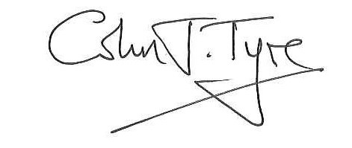
© CROWN COPYRIGHT 2016

